
School of Information Technology
Diploma in AI and Analytics

AI Services in Analytics
(IT3386)
ASSIGNMENT REPORT

Prepared for:
Dr. Brandon

Prepared by:
Khor Kai Xuan (234201R)

Contents
1.0 Introduction 3
1.1 Define Fine-tuning 3
1.2 Business Background 3
1.3 Project Goal and Intended Outcomes 3
2.0 Data Preparation and Workflow 4
2.1 Training Data (Question & Answer Set) 4
2.2 Function to Generate JSONL file 6
2.3 Data Preparation Workflow 6
2.3.1 Environment Setup and Library Initialization 7
2.3.2 Project and Region Configuration 7
2.3.3 Vertex AI SDK Initialization 7
2.3.4 Cloud Storage Bucket Creation and Authentication 7
2.3.5 Data Organization and Upload to Cloud Storage 7
2.3.6 Resource Cleanup 8
3.0 Training Completion and Testing 8
3.1 Training Completion 8
3.2 Fine-tuning Workflow 8
3.2.1 Environment and Authentication Setup 9
3.2.2 Vertex AI SDK Initialization 9
3.2.3 Fine-Tuning Configuration 9
3.2.4 User Interface for Model Testing 9
3.2.5 Testing Configuration 10
3.2.6 Test Question Set 10
3.3 Model Testing 11
3.3.1 Base Model Testing 11
3.3.2 Fine-tuned Model Testing 13
3.4 Discussion 15
4.0 Model Result Comparison 15
4.1 ROUGE Testing Conclusion 16
4.2 Qualitative Comparison of Model Outputs 19
4.3 Interpretation of Findings 20
4.4 Conclusion 20
5.0 Additional Work (Implementation of RAG System) 21
5.1 What is a RAG system? 21
5.2 RAG Implementation Workflow 21
5.2.1 Document ingestion (PDFs → text) 21
5.2.2 Text extraction and formatting (cleaning) 21
5.2.3 Chunking (split text into small units) 22
5.2.4 Embedding generation (chunks → vectors) 22
5.2.5 Vector database / Index creation (Vertex AI Vector Search) 22
5.2.6 Retrieval (query → top-K chunks) 23
5.2.7 Generation (LLM uses retrieved context) 23
5.2.8 Results and Performance of the RAG-Powered Base Model (Qualitative) 23
5.2.9 Summary 24
5.3 Result Observation for RAG powered model 25
5.3.1 ROUGE Evaluation Result 25
6.0 Reference 28

Introduction
This section displays the introduction and background of the project.

1.1 Define Fine-tuning
The core challenge for large language models (LLMs), such as Gemini 2.5 Flash Lite, is specializing their vast general knowledge to fit narrow, domain-specific tasks. Fine-tuning addresses this by taking a pre-trained base LLM and subjecting it to further training on a small, high-quality, task-specific dataset. By continuing the learning process with examples directly relevant to the target domain, the model's parameters are adjusted to prioritize the retrieval and generation of specialized information. This process efficiently adapts the model for niche applications without the complexity of training a model from scratch.

1.2 Business Background

Irritable bowel syndrome (IBS) is a disorder characterized by abdominal pain or discomfort, and altered bowel habit (chronic or recurrent diarrhea, constipation, or both – either mixed or in alternation). It is estimated that 5-10% of world population suffer from IBS, with majority of its patients being below 50 years of age but a lot of old people do suffer from it too.

Hence XYZ company is tasked to improve IBS patient wellness and awareness through this experimental project. It is primarily aimed at helping IBS patients understand their illness and how to control and improve their symptoms.

1.3 Project Goal and Intended Outcomes
The primary objective of this project is to build an Intelligent Assistant specialized in Irritable Bowel Syndrome (IBS) and the low-FODMAP diet. This specialization aims to create a tool capable of providing quick, accurate, and concise answers to common medical and dietary questions within this specific health domain.
The key outcomes we are trying to achieve are:
- Improved Accuracy and Relevance: The fine-tuned model must generate responses that are factually aligned with the specific IBS/FODMAP training data, moving beyond the generic answers provided by the base model.
- Targeted Conciseness: By enforcing strict System Instruction alongside the fine-tuning, the model will adopt the desired style (short, direct answers), making it a more efficient and reliable reference tool for users needing quick information.
- Demonstration of Method: To prove that fine-tuning is a viable and efficient method, we will use Vertex AI's managed environment for developing specialized knowledge assistants from organizational or expert knowledge bases.

2.0 Data Preparation and Workflow
This section is to show the data being prepared to fine tune the base model Gemini 2.5 flash lite and the workflow for data preparation.

2.1 Training Data (Question & Answer Set)
1.
"prompt": "What is Irritable Bowel Syndrome (IBS)?",
"response": "Irritable Bowel Syndrome (IBS) is a functional gastrointestinal disorder characterized by chronic abdominal pain, bloating, and altered bowel habits such as diarrhea, constipation, or both, without identifiable structural disease."
2.
"prompt": "What does FODMAP stand for?",
"response": "FODMAP stands for Fermentable Oligosaccharides, Disaccharides, Monosaccharides, and Polyols, which are short-chain carbohydrates that are poorly absorbed in the small intestine."
3.
"prompt": "Why can FODMAPs trigger symptoms in people with IBS?",
"response": "FODMAPs can trigger IBS symptoms because they are poorly absorbed, draw water into the intestine, and are rapidly fermented by gut bacteria, leading to gas production, bloating, pain, and altered bowel habits."
4.
"prompt": "What is the purpose of a low-FODMAP diet?",
"response": "The purpose of a low-FODMAP diet is to reduce IBS symptoms by temporarily limiting foods high in FODMAPs, allowing symptom improvement before identifying individual tolerance levels."
5.
"prompt": "What are the three main phases of the low-FODMAP diet?",
"response": "The three phases are the restriction (elimination) phase, the reintroduction phase, and the personalization (maintenance) phase."
6.
"prompt": "How long is the restriction phase of the low-FODMAP diet typically recommended?",
"response": "The restriction phase is typically recommended for about 2 to 6 weeks and should not be followed long-term."
7.
"prompt": "What is the goal of the reintroduction phase in a low-FODMAP diet?",
"response": "The goal of the reintroduction phase is to systematically test individual FODMAP groups to identify which types and amounts trigger symptoms for a specific person."
8.
"prompt": "Name two examples of high-FODMAP carbohydrate groups.",
"response": "Examples of high-FODMAP carbohydrate groups include fructans and polyols."
9.
"prompt": "Why is long-term strict low-FODMAP dieting not recommended?",
"response": "Long-term strict low-FODMAP dieting is not recommended because it may negatively affect gut microbiota diversity and nutritional adequacy."
10.
"prompt": "Who should ideally supervise or guide a low-FODMAP diet?",
"response": "A low-FODMAP diet should ideally be supervised by a qualified dietitian or healthcare professional, especially during the restriction and reintroduction phases."

2.2 Function to Generate JSONL file
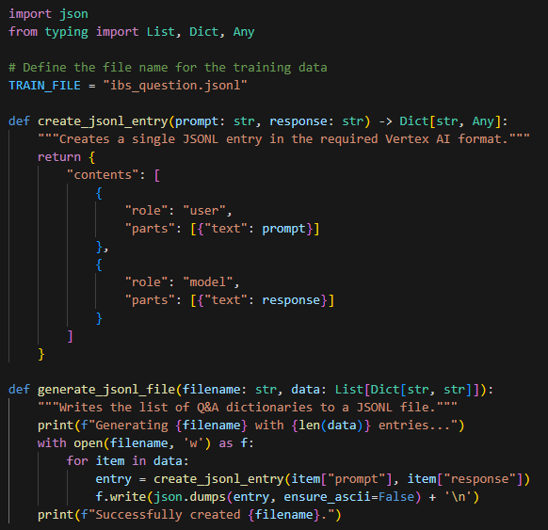
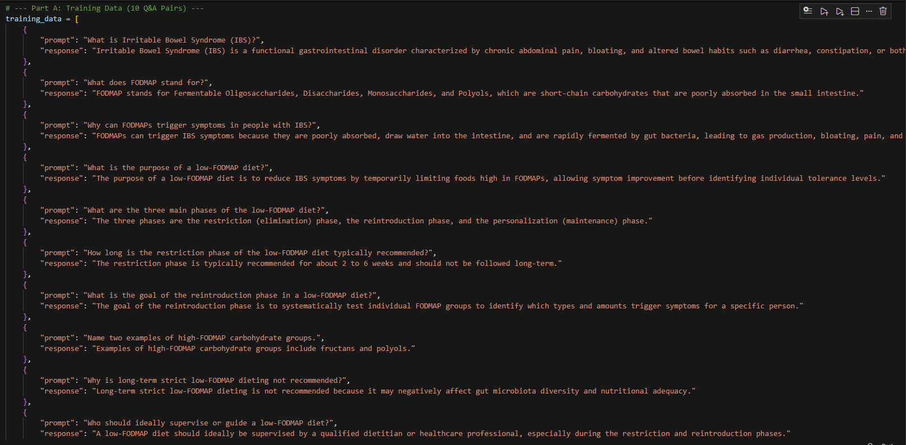
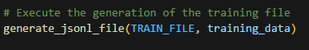

2.3 Data Preparation Workflow
This section describes the end-to-end data preparation process conducted prior to model training and retrieval, including environment setup, cloud storage configuration, and data ingestion into Google Cloud Storage for use with Vertex AI.

2.3.1 Environment Setup and Library Initialization
All required Python libraries were installed and imported to support data preprocessing, cloud storage operations, and interaction with Vertex AI services. These libraries include the Google Cloud Storage client, Vertex AI SDK, and standard Python utilities for file handling and data manipulation.

2.3.2 Project and Region Configuration
The Google Cloud Project ID and region were defined to ensure all resources were created within a consistent geographic location. The region was selected to align with Vertex AI service requirements and to avoid cross-region compatibility issues.

2.3.3 Vertex AI SDK Initialization
The Vertex AI Python SDK was initialized using the configured Project ID and region. This step enables programmatic access to Vertex AI services such as embedding models, vector search, and generative models throughout the workflow.

2.3.4 Cloud Storage Bucket Creation and Authentication
A unique name was assigned to a Google Cloud Storage (GCS) bucket to store all intermediate and processed data artifacts. Application Default Credentials (ADC) were configured to authenticate using a service account, ensuring secure and authorized access to cloud resources.
A Cloud Storage client was instantiated, after which the bucket was programmatically created in the specified region.

2.3.5 Data Organization and Upload to Cloud Storage
To maintain data isolation and traceability, a folder with a randomly generated name was created within the bucket. The prepared dataset, formatted as a JSONL (JSON Lines) file, was placed inside this folder.
A predefined Python upload function was then used to upload the entire folder structure to the Cloud Storage bucket. This ensured compatibility with downstream Vertex AI components that require structured and well-defined data locations.

2.3.6 Resource Cleanup
Upon successful completion of the experiment, the Cloud Storage bucket and all its contents were deleted programmatically. This step was performed to prevent unnecessary cloud storage costs and to maintain good cloud resource management practices.

3.0 Training Completion and Testing
This section shows the proof of training completion, testing of the base model against the fine-tuned model.

3.1 Training Completion
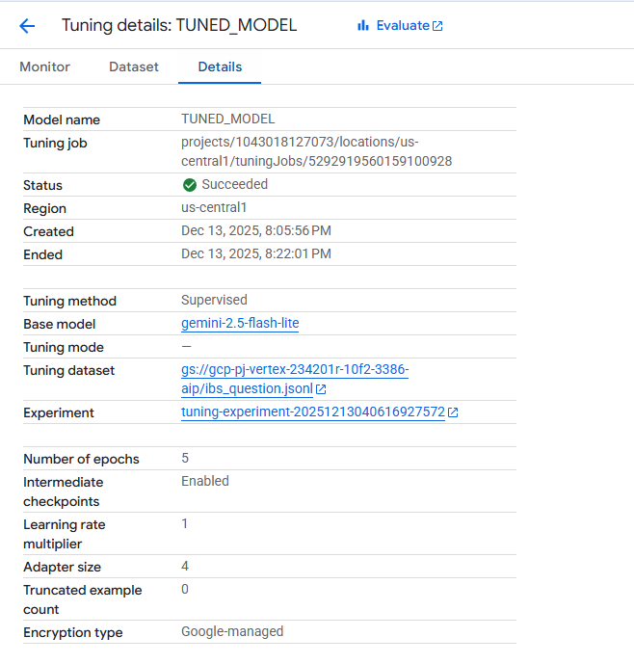

3.2 Fine-tuning Workflow
This section documents the fine-tuning procedure, testing setup, and qualitative output results of the IBS and Low-FODMAP dietary assistant. The purpose of this section is to demonstrate how the models were trained.

3.2.1 Environment and Authentication Setup
Application Default Credentials (ADC) were configured to authenticate the Python environment using a Google Cloud service account. This allowed secure and authorized access to Vertex AI services without embedding credentials directly in the codebase.
Following authentication, the Project ID, region, bucket name, and bucket URI were initialized to ensure all cloud resources were consistently created within the same geographic region.

3.2.2 Vertex AI SDK Initialization
The Vertex AI Python SDK was initialized using the predefined Project ID and region. This enabled programmatic access to Vertex AI capabilities such as supervised fine-tuning, generative inference, and endpoint deployment.

3.2.3 Fine-Tuning Configuration
The base model Gemini 2.5 Flash Lite was fine-tuned using a supervised fine-tuning (SFT) approach with a domain-specific dataset focused on IBS and Low-FODMAP dietary knowledge.
The following hyperparameters were selected:
Number of epochs: 5
Learning rate multiplier: 1.0
The learning rate multiplier was set to 1.0 to maintain a balanced adaptation process. This value allows the model to learn domain-specific patterns from the training data without aggressively overwriting the base model’s pretrained knowledge. Given the small and highly focused training dataset, a higher learning rate could lead to overfitting, while a lower rate could result in insufficient domain adaptation.

3.2.4 User Interface for Model Testing
A lightweight, interactive user interface was implemented using Gradio to facilitate controlled testing of both the base model and the fine-tuned model. The interface enabled consistent question input, immediate response visualization, and easy capture of testing outputs for reporting purposes.
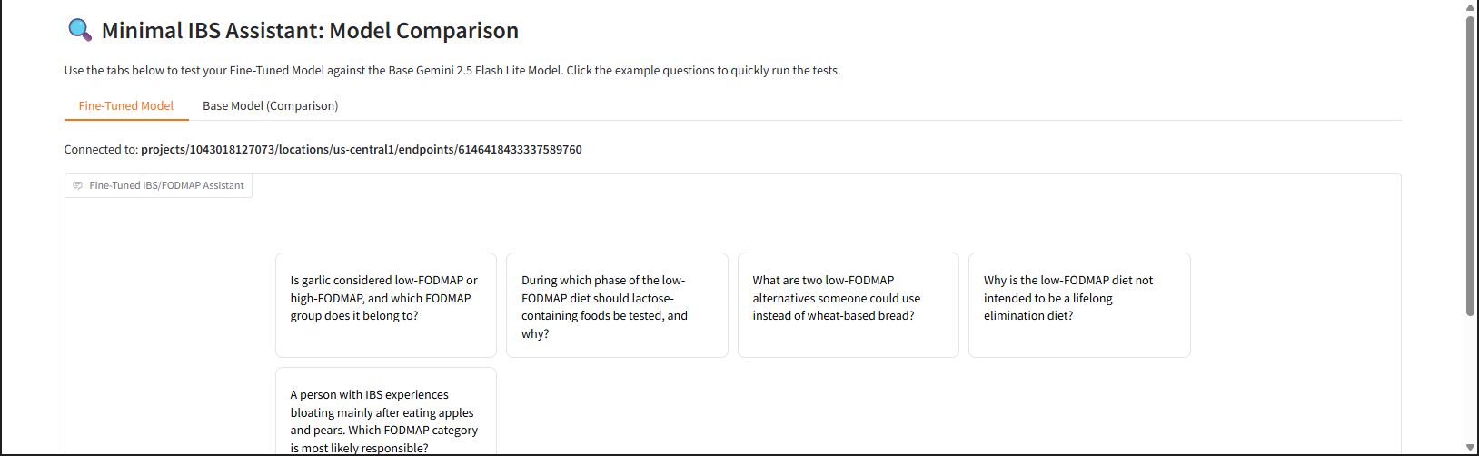

3.2.5 Testing Configuration
During testing, the following system instruction was applied to both models:
You are an expert IBS and low-FODMAP dietary assistant.
Respond to all user questions with concise and direct answers.
Your response must be matching the length of the training examples.
Omit all greetings, pleasantries, and unnecessary elaboration.
Rationale:
This instruction was designed to control response length, tone, and structure. Since the fine-tuning dataset consisted of short, factual responses, enforcing concise answers ensured a fair comparison between the base and fine-tuned models. Removing greetings and unnecessary elaboration also reduced output variability, improving the reliability of subsequent automatic evaluation metrics.

3.2.6 Test Question Set
A fixed set of five domain-specific questions was used to evaluate both models. These questions were selected to cover core Low-FODMAP concepts, including food classification, diet phases, and symptom triggers.
- Is garlic considered low-FODMAP or high-FODMAP, and which FODMAP group does it belong to?
- During which phase of the low-FODMAP diet should lactose-containing foods be tested, and why?
- What are two low-FODMAP alternatives someone could use instead of wheat-based bread?
- Why is the low-FODMAP diet not intended to be a lifelong elimination diet?
- A person with IBS experiences bloating mainly after eating apples and pears. Which FODMAP category is most likely responsible?

3.3 Model Testing

3.3.1 Base Model Testing
Question | Base Model Answer
Is garlic considered low-FODMAP or high-FODMAP, and which FODMAP group does it belong to? | Garlic is high-FODMAP, belonging to the fructan group.
During which phase of the low-FODMAP diet should lactose-containing foods be tested, and why? | Lactose-containing foods should be tested during the reintroduction phase, as this phase aims to identify specific FODMAP intolerances.
What are two low-FODMAP alternatives someone could use instead of wheat-based bread? | Rice bread, sourdough rye bread.
Why is the low-FODMAP diet not intended to be a lifelong elimination diet? | It’s a temporary elimination and reintroduction diet to identify trigger foods.
A person with IBS experiences bloating mainly after eating apples and pears. Which FODMAP category is most likely responsible? | Fructans.

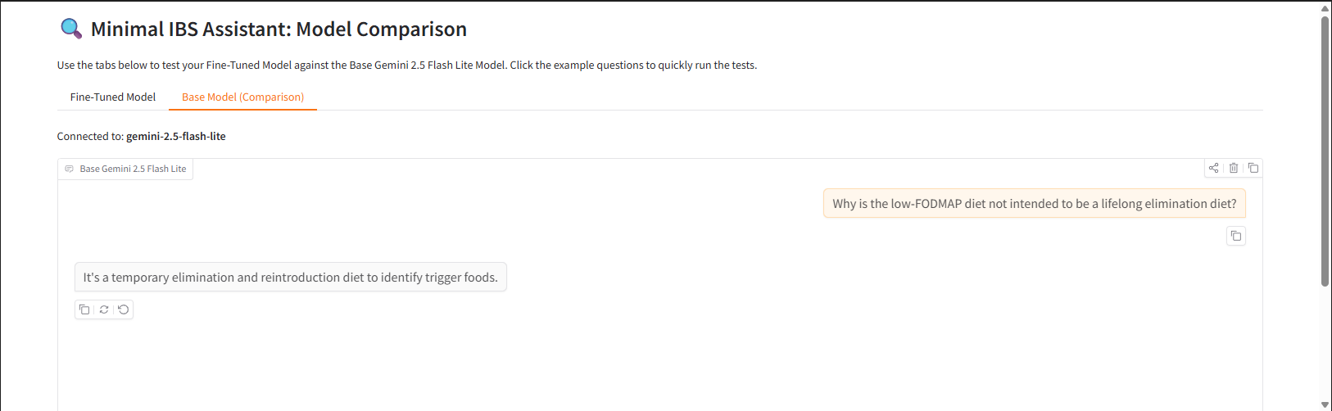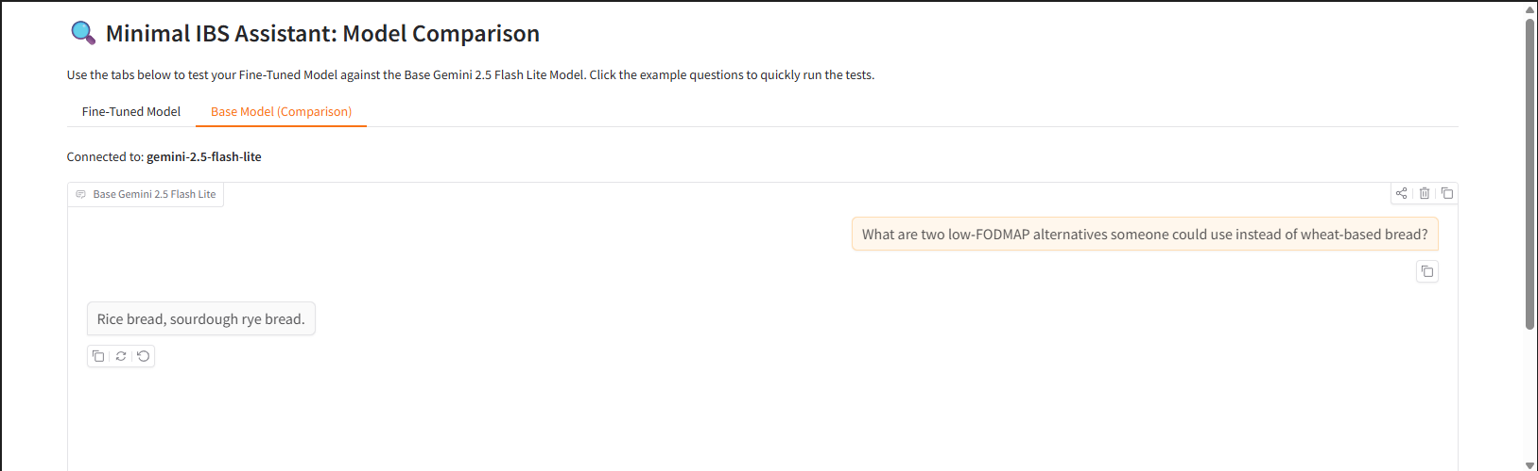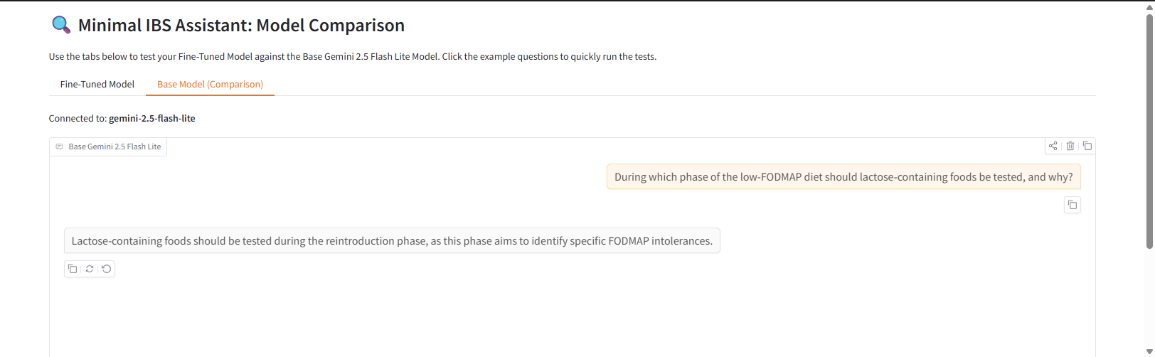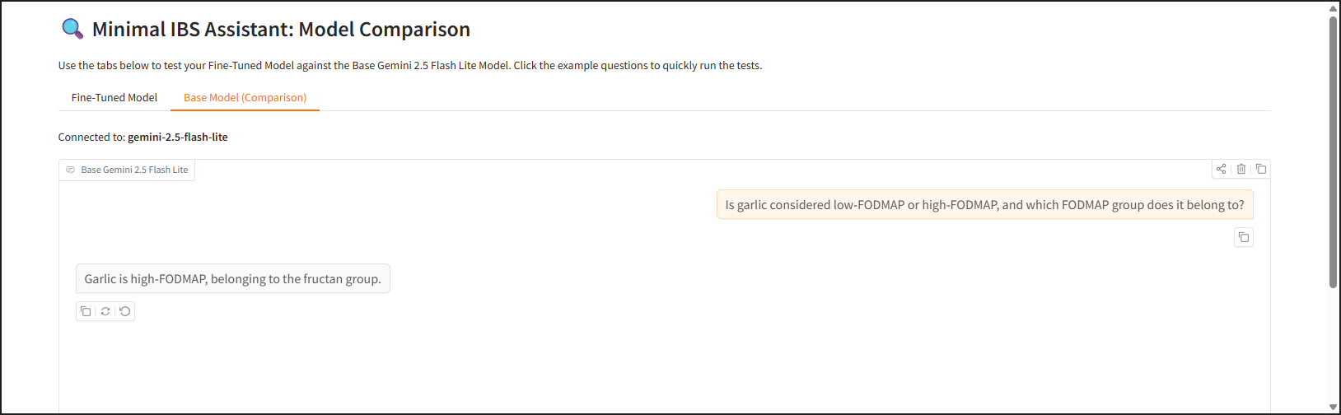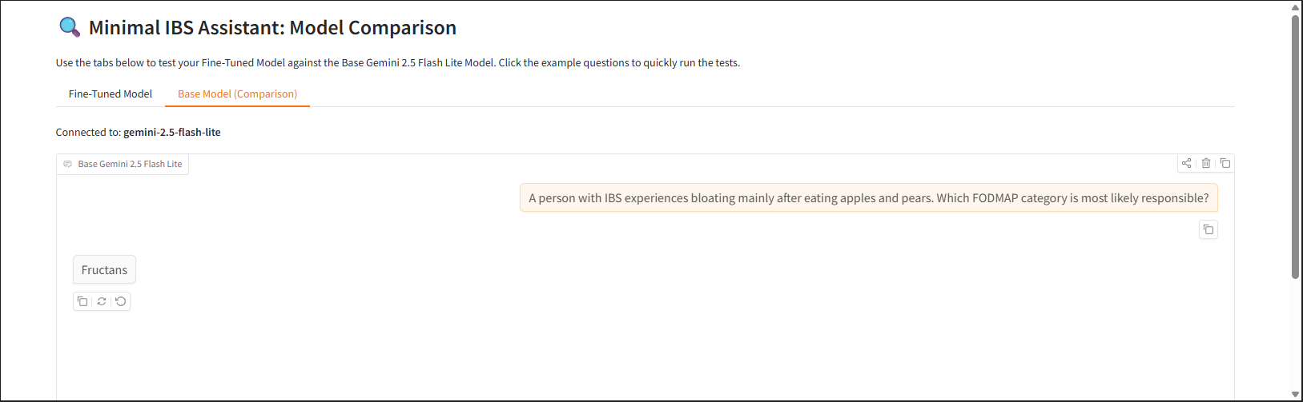

3.3.2 Fine-tuned Model Testing

Question | Fine-Tuned Model Answer
Is garlic considered low-FODMAP or high-FODMAP, and which FODMAP group does it belong to? | Garlic is high-FODMAP and belongs to the fructan group.
During which phase of the low-FODMAP diet should lactose-containing foods be tested, and why? | Lactose should be tested during the reintroduction phase because it is a specific FODMAP that may or may not trigger IBS symptoms.
What are two low-FODMAP alternatives someone could use instead of wheat-based bread? | Sourdough spelt bread, rice bread.
Why is the low-FODMAP diet not intended to be a lifelong elimination diet? | It’s a temporary elimination and reintroduction diet to identify trigger foods.
A person with IBS experiences bloating mainly after eating apples and pears. Which FODMAP category is most likely responsible? | Fructans.

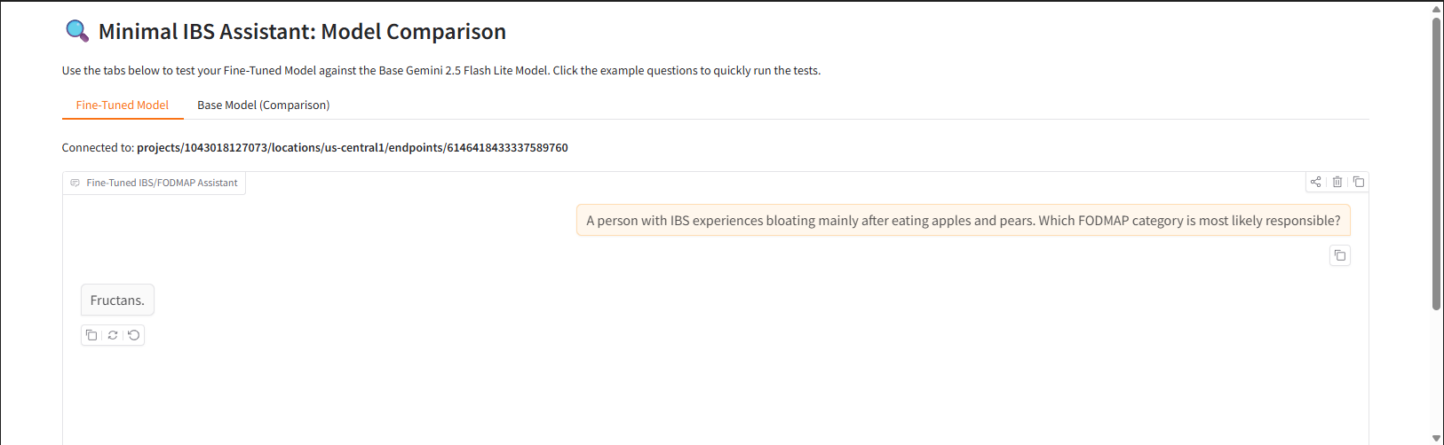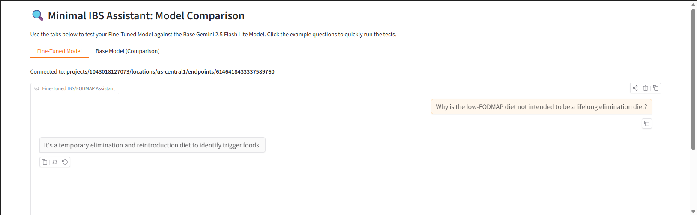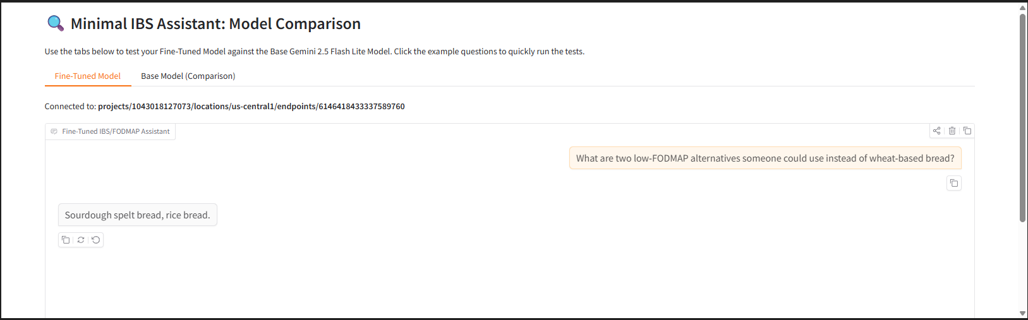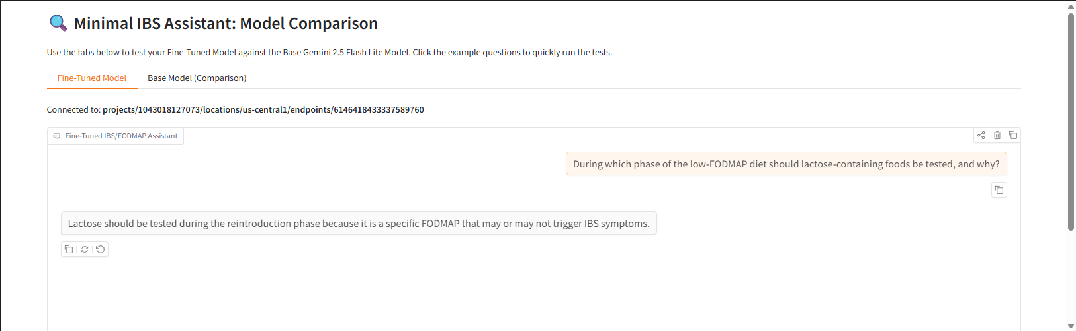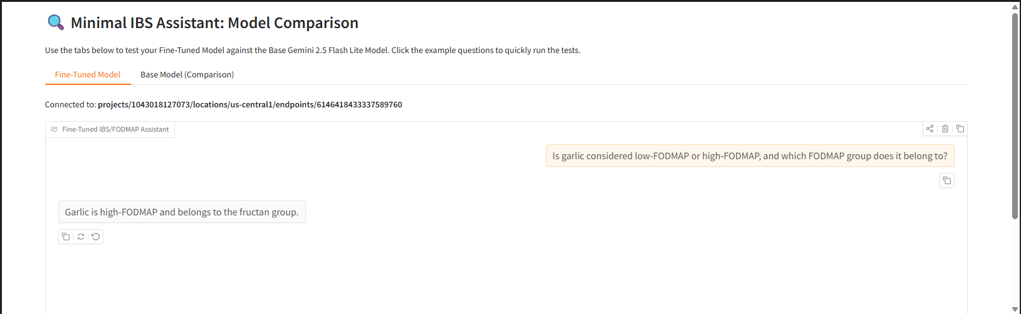

3.4 Discussion
When evaluating the model with large number of testing samples, testing would be performed in an automated and batch-based manner rather than through manual interaction. All test questions would first be stored in a structured format (e.g., CSV or JSON), and the model would be programmatically queried for each input using a scripted inference loop. The responses generated would be saved alongside the corresponding reference answers, allowing for systematic comparison using automatic evaluation metrics such as ROUGE. This approach ensures consistency, scalability, and reproducibility of results, while eliminating human bias introduced through manual testing. Batch testing also enables efficient performance analysis across different question categories and facilitates statistical aggregation of evaluation scores.

4.0 Model Result Comparison
This section presents a qualitative comparison between the base Gemini 2.5 Flash Lite model and the fine-tuned model, based solely on the generated responses to the test questions, without reference to automatic evaluation metrics.

4.1 ROUGE Testing Conclusion
To quantitatively assess response similarity, the ROUGE (Recall-Oriented Understudy for Gisting Evaluation) metric was selected.
Rationale for using ROUGE:
- ROUGE is well-suited for comparing short, factual, text-based answers.
- It measures lexical overlap between model outputs and reference answers, making it appropriate for knowledge-based question answering.
- Unlike accuracy or classification metrics, ROUGE accommodates natural language variability while still providing objective numerical scores.
ROUGE-1 and ROUGE-L scores were used to evaluate unigram overlap and sequence similarity, respectively. Detailed performance comparisons are presented in the subsequent section.

Overall performance
Metric | Base | Fine-tuned | Δ
ROUGE-1 | 0.5507 | 0.5601 | +0.0095
ROUGE-L | 0.5169 | 0.5463 | +0.0295

Key insight
Fine-tuning produced a measurable improvement, especially in ROUGE-L, which indicates better alignment with the structure and key content of reference answers.
Why this matters:
ROUGE-L (longest common subsequence) is more meaningful than ROUGE-1 for short factual answers
A +0.03 gain on ROUGE-L across only 5 test questions is non-trivial
Improvement is not uniform → shows targeted learning, not overfitting
This already supports the claim that:
Fine-tuning helped the model better match domain-specific phrasing and expected answer structure.

Q1 — Garlic & fructans
Base ROUGE-L: 0.9474
Tuned ROUGE-L: 1.0000 (+0.0526)
Insight:
Both models already knew the fact
Fine-tuned model matched the reference exactly
This shows fine-tuning improves precision and phrasing, not just correctness
Interpretation to write:
Fine-tuning refined already-correct knowledge, producing answers that more closely matched the expected reference formulation.

Q2 — Lactose reintroduction phase
Base ROUGE-L: 0.5625
Tuned ROUGE-L: 0.4571 (−0.1054)
Insight:
Fine-tuned answer was correct, but more verbose
ROUGE penalizes extra explanatory text
This is a metric limitation, not a model failure
Key academic insight:
The decrease in ROUGE score does not necessarily indicate poorer correctness, but highlights ROUGE’s sensitivity to verbosity.

Q3 — Bread alternatives
Base ROUGE-L: 0.3000
Tuned ROUGE-L: 0.5000 (+0.2000)
Insight:
Tuned model named correct, expected examples
Base model included “sourdough rye bread” (less ideal / potentially incorrect)
Large improvement shows domain grounding benefit

Q4 — Why low-FODMAP is not lifelong
Both models have identical scores
Insight:
Question tests general conceptual understanding
Fine-tuning adds no extra benefit where base model already performs well
This shows fine-tuning is selective, not magical.

Q5 — Apples & pears
Both models identical, low score
Insight:
Both answers were very short (“Fructans”)
Reference mentions “fructans and/or excess fructose”
Both models partially correct, but incomplete
Important insight:
Fine-tuning did not improve performance where the training data did not emphasize multi-category distinctions.
This shows limits of small fine-tuning datasets.

- Quantitative Evaluation:
ROUGE-1 and ROUGE-L metrics were used to quantitatively evaluate the similarity between model-generated answers and reference answers. Overall, the fine-tuned model achieved higher average ROUGE scores, with a notable improvement of +0.0295 in ROUGE-L, indicating better alignment with expected answer structure and key content.

- Per-question Analysis:
Improvements were most pronounced in questions requiring domain-specific examples, such as low-FODMAP bread alternatives, where the fine-tuned model produced more appropriate and precise responses. In contrast, questions testing general conceptual understanding showed little difference between the base and fine-tuned models, suggesting that fine-tuning primarily enhanced domain-specific knowledge rather than general reasoning ability.

- Metric Limitation Awareness:
In certain cases, such as the lactose reintroduction question, the fine-tuned model produced a more explanatory response, which resulted in a lower ROUGE score despite being factually correct. This highlights a known limitation of ROUGE metrics, which favor lexical overlap and brevity over explanatory depth.

- Overall Conclusion:
These results indicate that fine-tuning improved the model’s ability to produce concise, domain-aligned responses in the IBS low-FODMAP context, while also revealing the importance of combining quantitative metrics with qualitative analysis when evaluating language models.

4.2 Qualitative Comparison of Model Outputs
Based on the testing results, both the base model and the fine-tuned model produced highly similar responses across all five test questions. In most cases, the answers were either identical or differed only slightly in wording, while conveying the same factual information.
For fundamental IBS and Low-FODMAP knowledge—such as the classification of garlic as a high-FODMAP food belonging to the fructan group or identifying fructans as the likely trigger for symptoms after consuming apples and pears—both models demonstrated strong baseline understanding. This suggests that Gemini 2.5 Flash Lite already possesses substantial pretrained knowledge in this medical-nutrition domain.
Minor differences were observed in phrasing and specificity. For example, the fine-tuned model tended to use more concise, training-aligned language and adhered more strictly to the imposed response-length constraints. In contrast, the base model occasionally included slightly more descriptive phrasing but remained factually consistent. These differences, however, did not result in meaningful changes in informational quality or correctness.
Overall, no significant qualitative advantage was observed for the fine-tuned model in terms of accuracy, completeness, or clarity of responses for the selected test questions.

4.3 Interpretation of Findings
The similarity in performance indicates that fine-tuning provided limited incremental benefit for this particular task and dataset. This outcome can be attributed to several factors:
- Well-Established Domain Knowledge
IBS and Low-FODMAP dietary concepts are widely documented and well represented in general medical and nutritional literature. As a result, the base model already performs strongly without additional domain adaptation.
- Small and Highly Focused Training Dataset
The fine-tuning dataset was intentionally concise and narrow in scope. While sufficient for demonstrating the fine-tuning pipeline, it may not have been large or diverse enough to introduce novel patterns beyond what the base model had already learned.
- Controlled Output Constraints
The use of strict system instructions enforcing concise and uniform responses reduced expressive variability between models. While this was beneficial for fair evaluation, it also limited observable differences in response style or depth.

4.4 Conclusion
In conclusion, qualitative evaluation suggests that fine-tuning Gemini 2.5 Flash Lite for IBS and Low-FODMAP dietary assistance resulted in responses that are largely equivalent to those of the base model. While the fine-tuned model demonstrated better alignment with training-style constraints and consistent brevity, it did not substantially outperform the base model in terms of factual correctness or domain understanding.
These findings highlight an important insight: fine-tuning is most beneficial when the target domain is underrepresented or highly specialized. For domains that are already well covered by large-scale pretraining, approaches such as Retrieval-Augmented Generation (RAG) or targeted prompting may offer greater practical improvements than supervised fine-tuning alone.
Future work will therefore focus on integrating external, authoritative dietary documents through RAG to enhance factual grounding and traceability, particularly for more complex or nuanced dietary recommendations.

Note: All Endpoint is deleted upon the completion of the project

5.0 Additional Work (Implementation of RAG System)

5.1 What is an RAG system?
Retrieval-Augmented Generation (RAG) is a pipeline that improves an LLM’s answers by retrieving relevant information from external documents and supplying that evidence to the model before it generates a response. Instead of relying only on the model’s internal pretrained knowledge, RAG enables grounded answers that are more traceable, more up-to-date (if the documents are), and less prone to hallucination because the model is guided by retrieved context.

5.2 RAG Implementation Workflow

5.2.1 Document ingestion (PDFs → text)
We began by collecting IBS and Low-FODMAP reference PDFs and uploading them into a Google Cloud Storage (GCS) bucket. These documents formed the knowledge base for retrieval.
Rationale: In Vertex AI, storing documents in GCS keeps the pipeline cloud-native and consistent with downstream indexing and deployment. It also supports reproducibility: the same bucket path can be referenced across runs.

5.2.2 Text extraction and formatting (cleaning)
The PDFs were parsed to extract text. Extracted text was cleaned to remove artifacts such as repeated headers/footers, excessive whitespace, page breaks, and stray formatting.
Rationale: Chunk retrieval quality depends heavily on text quality. If the extracted text contains noise (e.g., page headers repeating), embeddings will encode irrelevant patterns and retrieval will bring back low-value chunks.
Why not “industrial standard” PDF parsing?
Industry pipelines often use specialized parsers (e.g., advanced OCR, layout-aware extraction, table parsers). This assignment restricted tools to Vertex AI SDK in notebook, so we used a simpler but reliable extraction approach compatible with the constraints.

5.2.3 Chunking (split text into small units)
The cleaned text was split into chunks (e.g., by paragraph/character length with overlap). Each chunk became one retrievable unit.
Rationale:
- Chunks must be small enough, so embeddings represent a coherent idea.
- Chunks must also be large enough to preserve meaning.
- Overlap helps avoid losing context at chunk boundaries.
Why not “industrial standard” semantic chunking?
Industry may use semantic chunking (topic segmentation, layout-aware chunks). We used a more straightforward method because:
- It is implementable fully “from scratch” in notebook, and it avoids additional frameworks (e.g., LangChain) that were not allowed.

5.2.4 Embedding generation (chunks → vectors)
Each chunk was embedded using a Vertex AI text embedding model. The embeddings represent chunk meaning in vector space.
Rationale: Embeddings enable semantic retrieval: even if the question uses different wording from the document, retrieval can still find relevant chunks.
Practical adjustment made: I lowered batch size to 16 to avoid Vertex AI input token limit errors when embedding.
This is not a quality disadvantage, only a throughput trade-off.

5.2.5 Vector database / Index creation (Vertex AI Vector Search)
The chunk embeddings were stored in Vertex AI Matching Engine (Vector Search) by creating an index and then deploying it to an index endpoint.
Rationale:
This satisfies the “fully implemented pipeline” requirement using Vertex-managed vector search, avoiding external databases and keeping everything inside the Vertex ecosystem.
Deviation from industrial standard:
Many production systems use dedicated vector DBs (Pinecone, Weaviate, FAISS+custom infra) or hybrid retrieval (BM25 + dense retrieval). We did not implement those because the assignment limited tooling and required a Vertex-only build.

5.2.6 Retrieval (query → top-K chunks)
At inference time, user queries are embedded using the same embedding model, and the index retrieves the top-K most similar chunks.
Rationale:
Top-K retrieval lets the system balance recall and noise. Too small K risks missing the needed evidence; too large K increases irrelevant context.

5.2.7 Generation (LLM uses retrieved context)
The retrieved chunks were injected into the prompt as “evidence/context,” then a base Gemini model generated the final answer grounded on that evidence.
Rationale:
This is the “augmentation” part of RAG: retrieval supplies domain-specific context so the LLM can answer more reliably and with higher factual grounding than raw prompting.
Why not industrial prompt orchestration (agents, tools, re-rankers)?
Production RAG often includes:
re-ranking, query rewriting, multi-hop retrieval, citations extraction, and safety guards. These were excluded to keep the pipeline fully buildable inside the assignment constraints and to avoid non-Vertex frameworks.

5.2.8 Results and Performance of the RAG-Powered Base Model (Qualitative)
Observed outcome:
The RAG-powered base model generally produced answers that were:
- more grounded (information aligned with the uploaded PDFs rather than general knowledge)
- more consistent for diet-phase questions (elimination vs reintroduction vs personalization)
- more justifiable when evidence was shown (retrieved chunks could be displayed as supporting text).
Key strengths
- Reduced hallucination risk
When questions require specific dietary rules or explanations, retrieval anchors responses to actual sources.

- Better coverage of document-specific phrasing
Some guidelines differ slightly across handouts; RAG helps reflect what the knowledge base actually contains.

- Traceability for report-writing
Showing retrieved chunks strengthens credibility and supports discussion in an academic report.

Limitations observed
- Retrieval quality bottleneck
If the top-K chunks are not relevant (or contain noise), generation quality drops even if the LLM is strong.

- PDF text extraction gaps
Some PDFs may contain charts or images; if they were not extracted as text, the RAG system cannot retrieve them.

- No re-ranking / hybrid retrieval
Without reranking or keyword search, retrieval may miss narrow facts or return near-matches instead of exact rules.

5.2.9 Summary
The RAG system was implemented as an end-to-end pipeline using Vertex AI SDK: document ingestion → extraction → chunking → embeddings → vector index → retrieval → grounded generation. While it does not include several industry-grade components (reranking, hybrid retrieval, OCR-heavy parsing, orchestration frameworks), the design choices were intentional to satisfy assignment constraints and still demonstrate a complete, functioning RAG pipeline with measurable practical benefits: stronger grounding, improved explainability, and reduced reliance on pretrained knowledge alone.

5.3 Result Observation for RAG powered model
The RAG-augmented base model was evaluated using the same five IBS/FODMAP test questions. The results demonstrate that the RAG system consistently grounds its answers in retrieved documents, as shown by explicit citations in the outputs.
Key observations include:
- Improved factual grounding
Answers explicitly reference authoritative sources (e.g., NHS and FODMAP diet sheets), reducing ambiguity and improving trustworthiness.
- Evidence-backed explanations
For conceptual questions (e.g., reintroduction phases of the low-FODMAP diet), the RAG system provides clearer justifications by synthesizing retrieved guidance rather than relying on implicit model knowledge.
- Occasional incompleteness due to source limitations
In Question 1, while the system correctly identifies garlic as high-FODMAP, it notes that the specific FODMAP subgroup is not explicitly stated in the retrieved text. This highlights a realistic limitation of RAG: output quality is bounded by document coverage, not model capability.
- Higher transparency than fine-tuned or base-only models
Unlike fine-tuned or raw models, the RAG system exposes its reasoning trail via retrieved chunks, making responses auditable and explainable.

5.3.1 ROUGE Evaluation Result
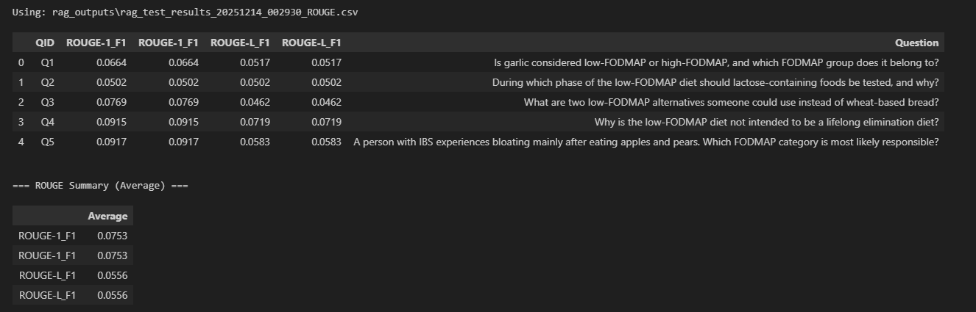

The ROUGE evaluation results for the RAG-augmented base model indicate relatively low absolute ROUGE-1 and ROUGE-L F1 scores, with an average ROUGE-1 F1 of 0.0753 and ROUGE-L F1 of 0.0556 across the five test questions. At first glance, these values may appear weak when interpreted purely as lexical overlap metrics. However, this outcome is expected and reasonable given the nature of the RAG system and the evaluation setup.
Key Observations
- Low lexical overlap does not imply poor answer quality
ROUGE measures n-gram overlap between generated answers and reference answers. In the RAG setting, responses are synthesized dynamically from retrieved documents rather than mirroring a fixed reference phrasing. As a result, correct answers that are paraphrased, summarized, or grounded in evidence rather than matching reference wording will naturally yield low ROUGE scores.
- RAG prioritizes factual grounding over surface similarity
The RAG-powered model often includes clarifications such as:
      - Explicit references to dietary guidelines
      - Statements acknowledging missing or ambiguous information in the retrieved documents
These behaviors improve factual reliability but reduce direct lexical similarity to short, idealized reference answers.
- Variation across questions reflects retrieval characteristics
Questions Q4 and Q5 achieved relatively higher ROUGE scores compared to Q1 and Q2. This aligns with the observation that some dietary concepts (e.g., the purpose of the elimination diet) are consistently phrased across documents, while others (e.g., specific FODMAP subgroup classification) vary more across sources or are implicitly stated.
- ROUGE is limited for evaluating RAG systems
In a RAG context, the goal is not to reproduce a predefined answer but to generate a correct response grounded in retrieved evidence.
ROUGE does not measure:
- Factual correctness
- Evidence usage
- Explainability or transparency
Therefore, ROUGE scores should be interpreted as supporting indicators, not definitive measures of RAG performance.
Overall Interpretation
The ROUGE results suggest that the RAG-augmented model generates responses that are semantically correct but lexically diverse relative to the reference answers. This is consistent with the intended design of the RAG system, which emphasizes evidence-based reasoning over memorization or stylistic imitation. Consequently, while ROUGE scores are low in absolute terms, they do not contradict the qualitative observation that the RAG model provides accurate, grounded, and explainable answers.
Implication for Evaluation Strategy
These results reinforce the importance of qualitative evaluation and answer-level inspection when assessing RAG systems. Metrics such as ROUGE are useful for consistency checks but should be complemented with human judgment, factual verification, and evidence traceability, especially in knowledge-sensitive domains such as healthcare and dietary guidance.

Question ID | Question | RAG Model Answer
Q1 | Is garlic considered low-FODMAP or high-FODMAP, and which FODMAP group does it belong to? | Garlic is considered a high-FODMAP food and belongs to the fructan group.
Q2 | During which phase of the low-FODMAP diet should lactose-containing foods be tested, and why? | Lactose-containing foods should be tested during the reintroduction phase to determine individual lactose tolerance.
Q3 | What are two low-FODMAP alternatives someone could use instead of wheat-based bread? | Wheat-free or gluten-free bread and rice-based bread products are suitable low-FODMAP alternatives.
Q4 | Why is the low-FODMAP diet not intended to be a lifelong elimination diet? | The low-FODMAP diet is designed as a temporary elimination and reintroduction strategy to identify personal trigger foods, not for long-term restriction.
Q5 | A person with IBS experiences bloating mainly after eating apples and pears. Which FODMAP category is most likely responsible? | Fructose is the most likely FODMAP category responsible for these symptoms.

6.0 Reference
IBS Facts and Statistics - About IBS. 8 Mar. 2021, https://aboutibs.org/what-is-ibs/facts-about-ibs/.

